Chapter 5, Solution 16

Using Fig. 5.55, design a problem to help students better understand inverting op amps.

Although there are many ways to work this problem, this is an example based on the same kind of problem asked in the third edition.

Problem

Obtain i_{x} and i_{y} in the op amp circuit in Fig. 5.55.

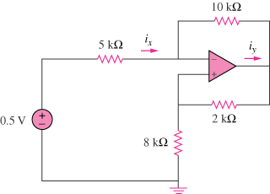

Figure 5.55

Solution
10k

i_{x}
5k v_{a} i_{y}
-
v_{b} + v_{o}

+ 2k
0.5V
- 8k

Let currents be in mA and resistances be in k. At node a,
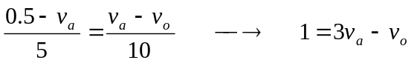 (1)

But
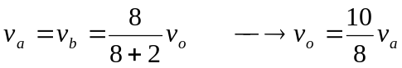 (2)
Substituting (2) into (1) gives
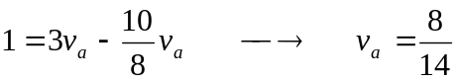
Thus,
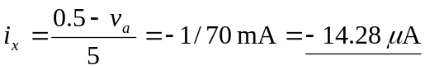

= 85.71 µA

